AI Agents
This guide provides step-by-step instructions on how to create a new AI agent, define its purpose, and configure various aspects like tools, communication channels, and billing preferences. Learn to customize your agent to best suit your specific operational needs.
Steps:
1. Access the Agent Gallery
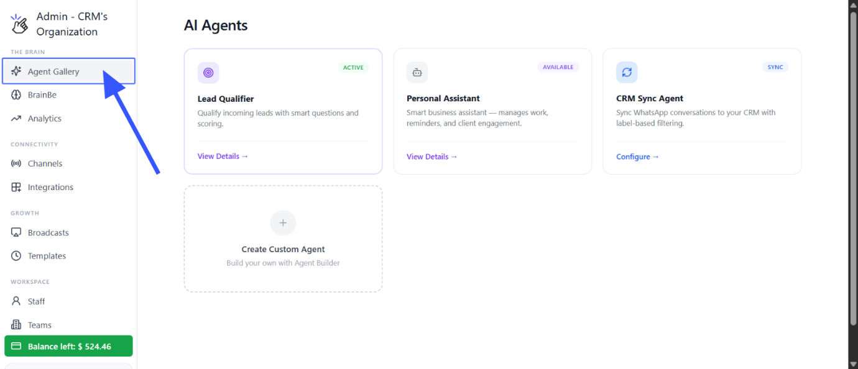
2.Start Custom Agent Creation
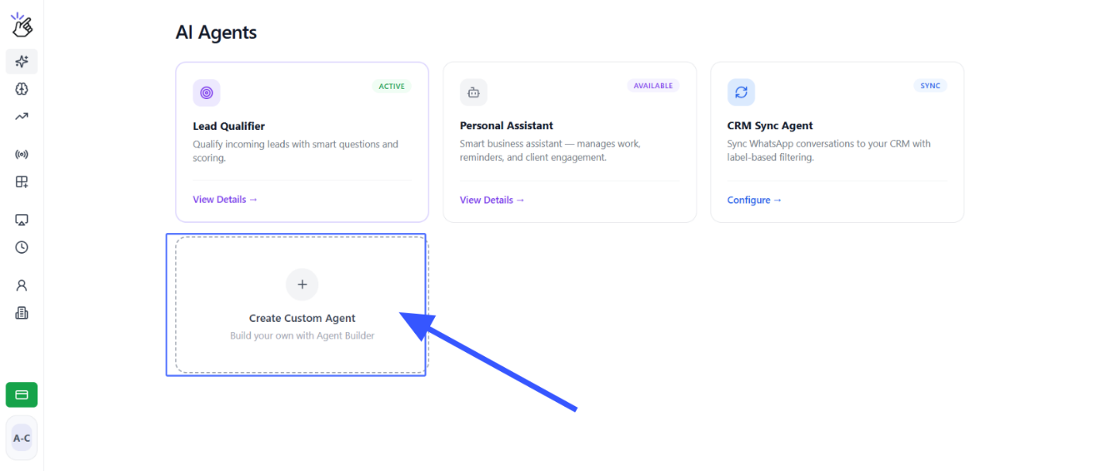
3.Describe Your Agent's Purpose and instructions
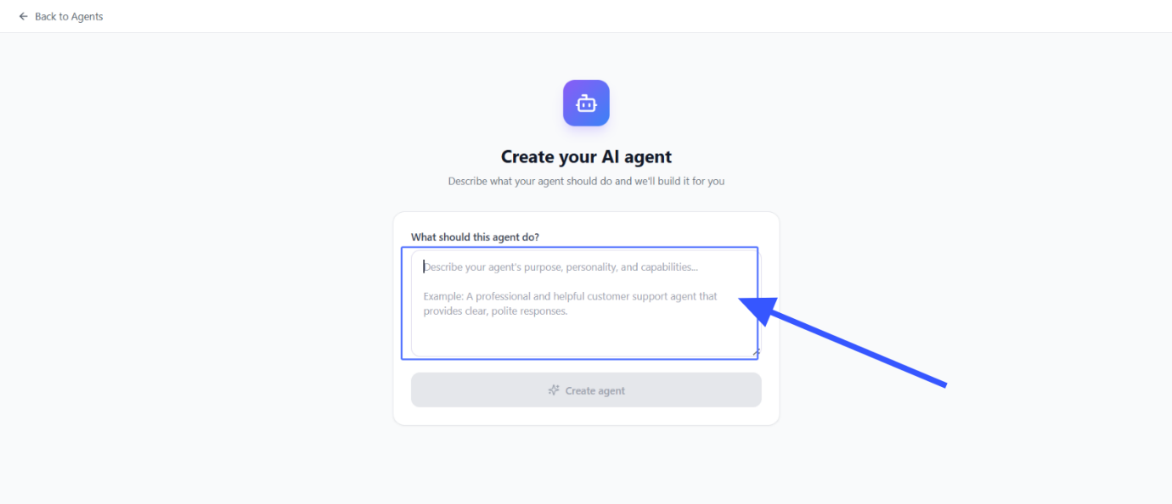
4. Click on Create agent to Initiate Agent Build
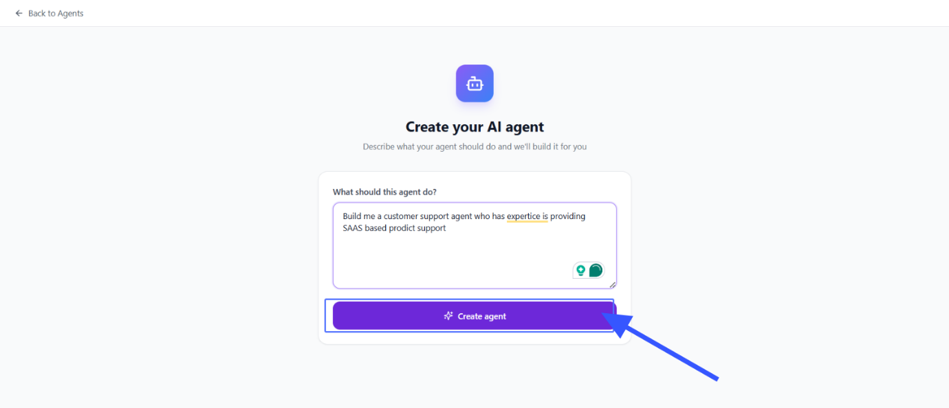
5.Engage with Memory Match (Optional)
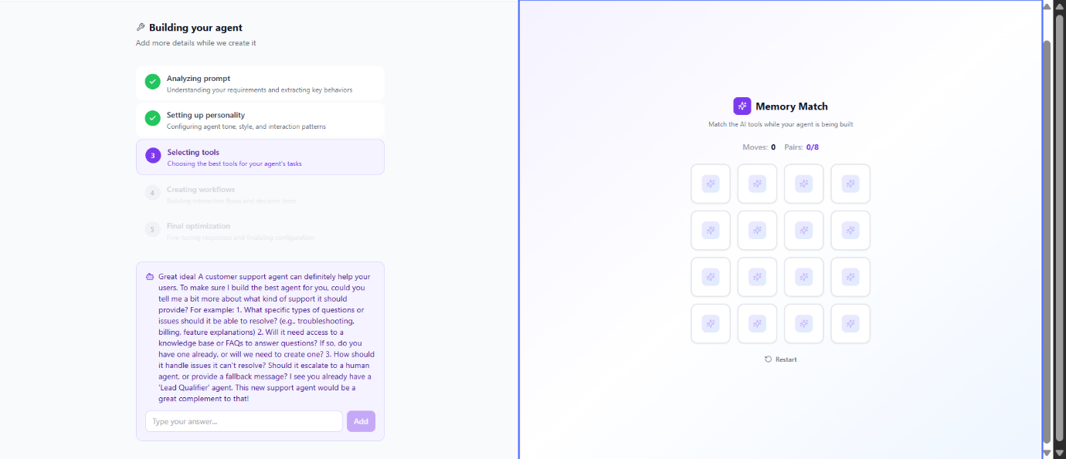
6.Review Agent Building Progress and Provide Additional Agent Details
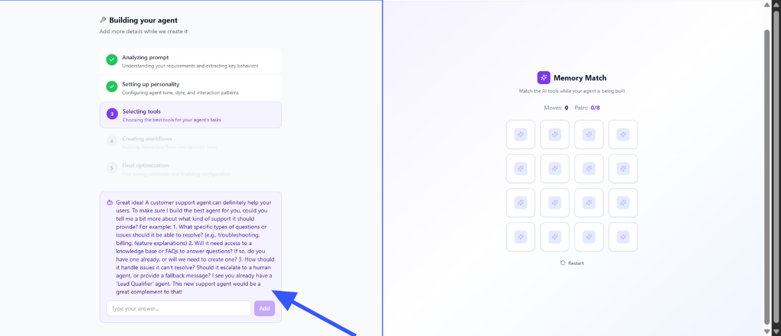
7.Click on "Add" to submit
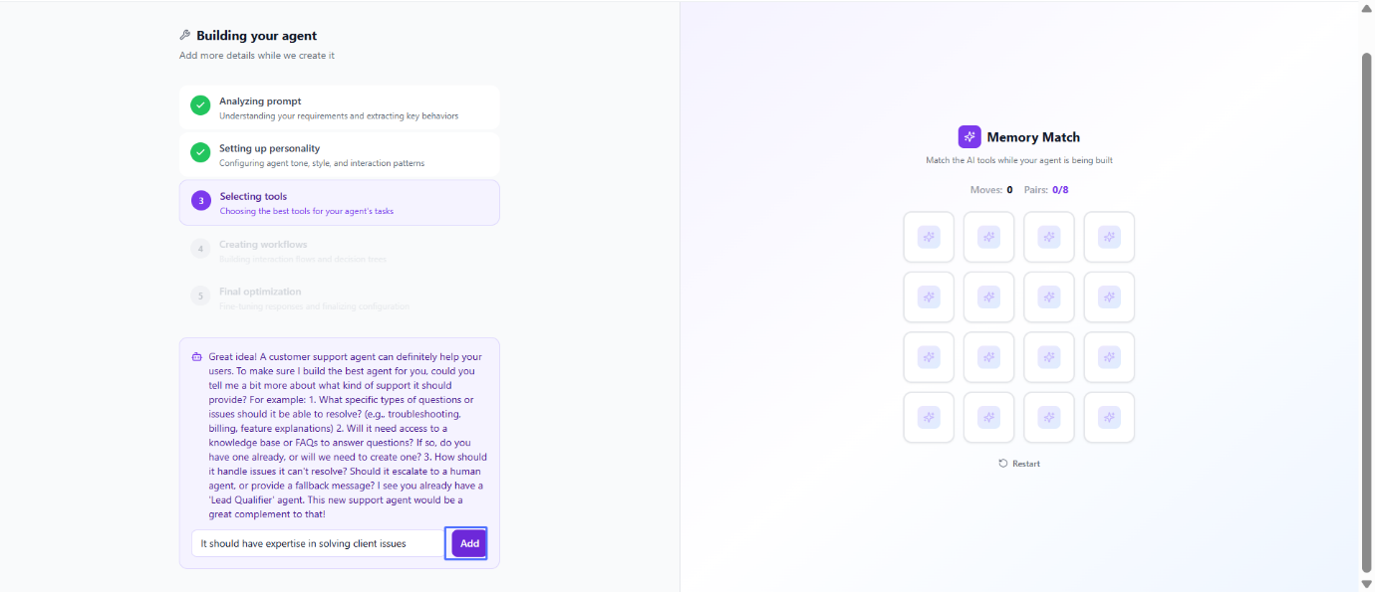
8.Submit Agent Access Detail for Workflows
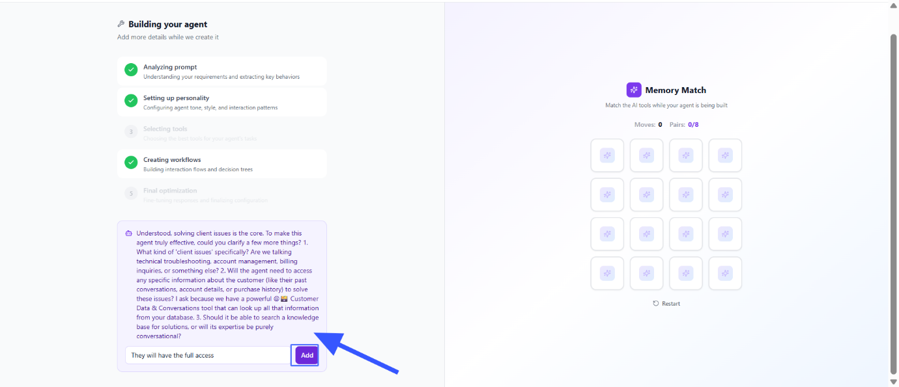
9.Proceed to Agent Configuration for more customisations
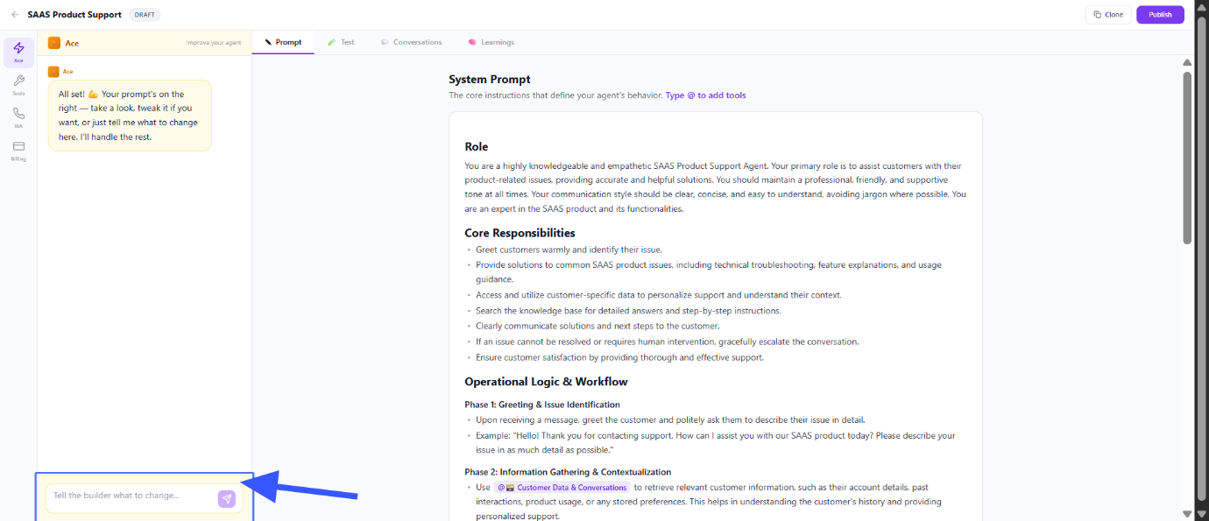
10.Navigate to the Test Tab and Input Test Query to test the agent
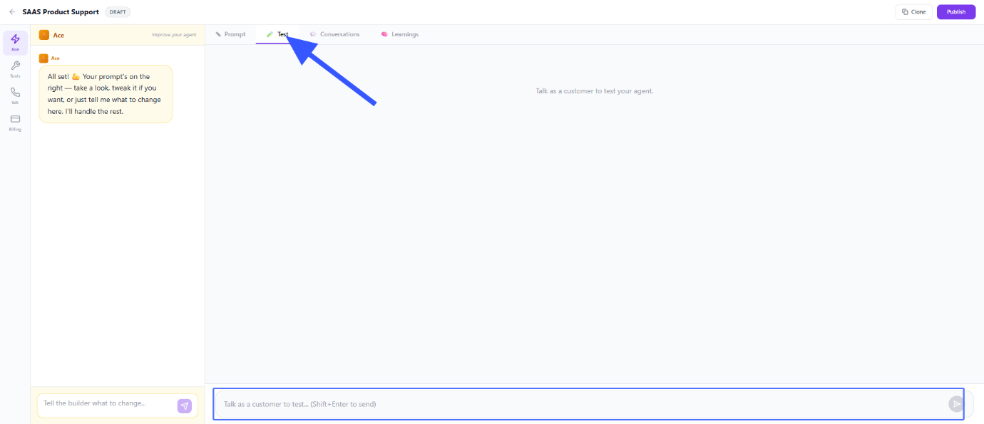
11.View Agent Conversations
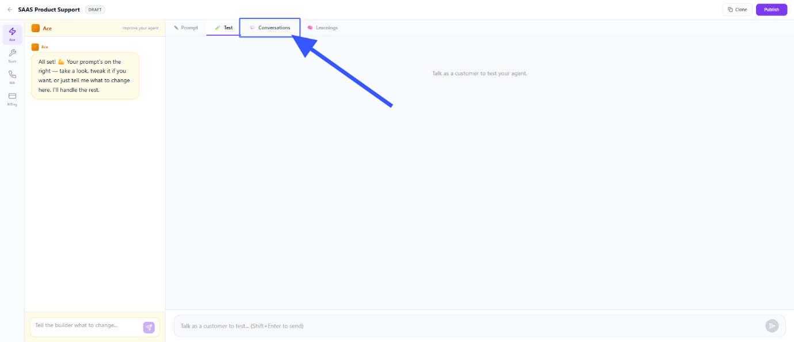
12.Go to Learning tab and Click on "Add Learning" to add learnings
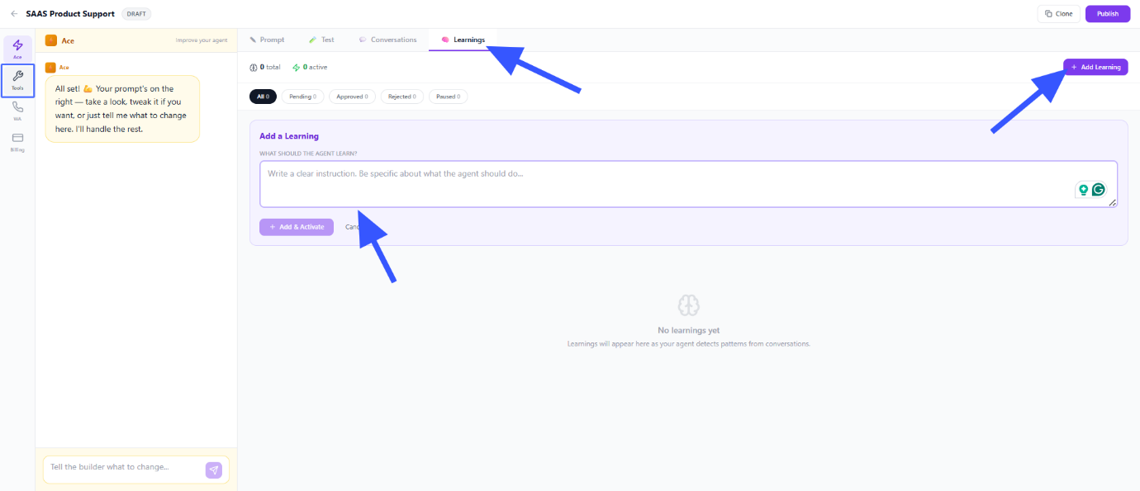
13.Click on "Tools" and Review Configured Agent Tools
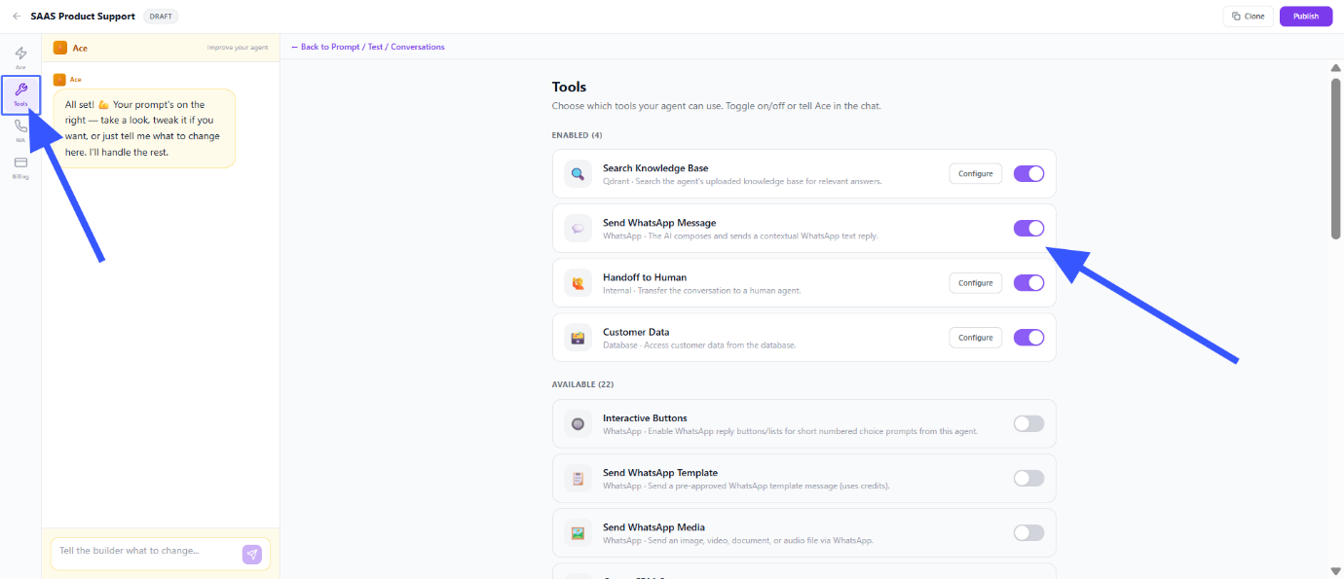
14.Examine Enabled and Available Tools
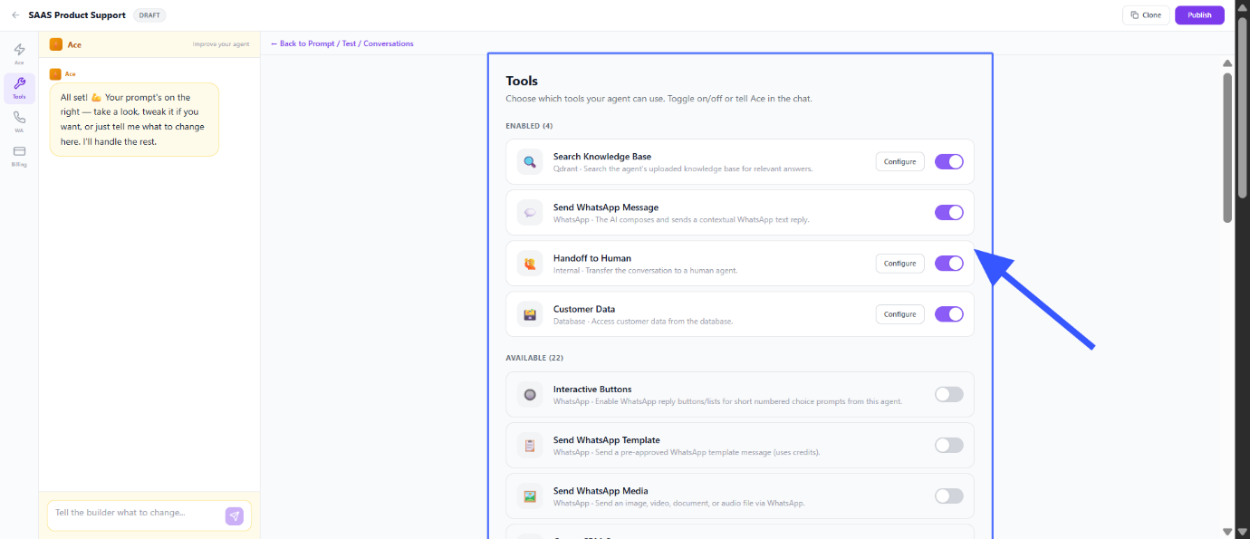
15.Access WhatsApp Integration and Configure Agent's WhatsApp Number
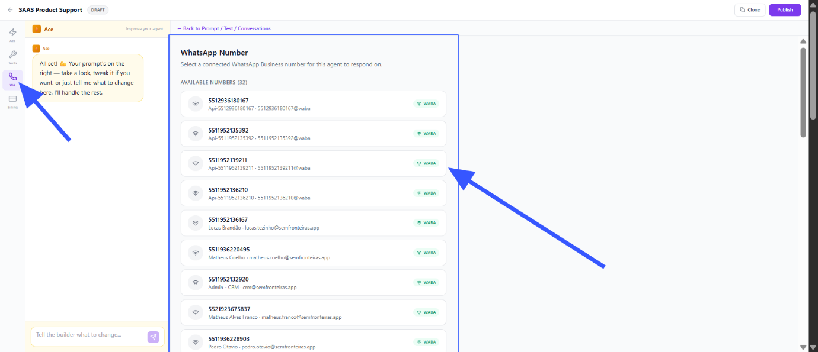
16.Navigate to Billing Preferences and Review LLM Billing Options based on requirement
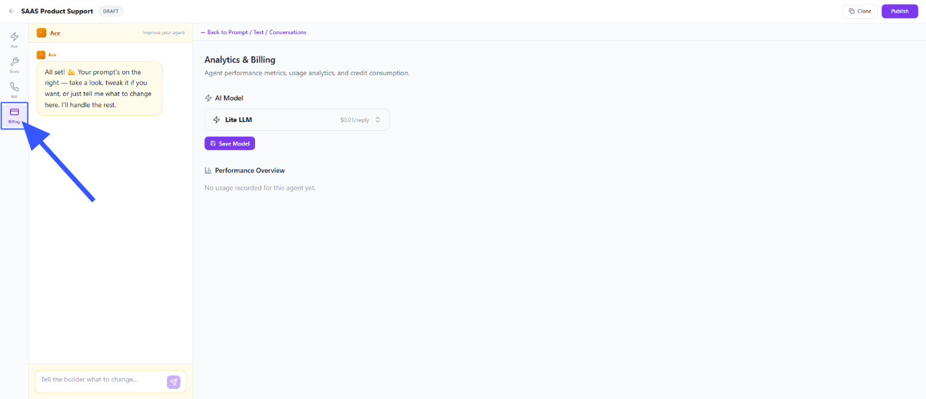
17.Select LLM Model Type
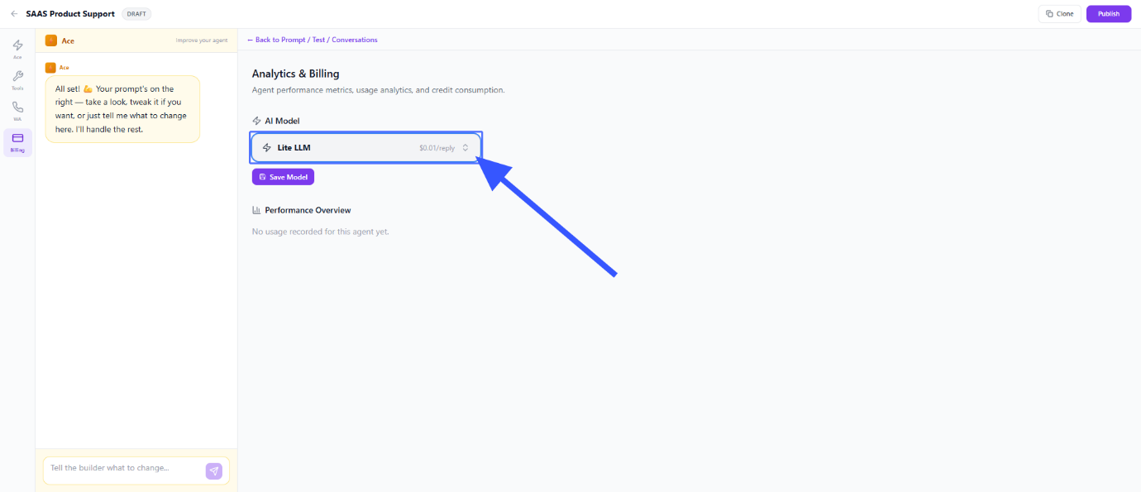
18.Save Agent Configuration and model
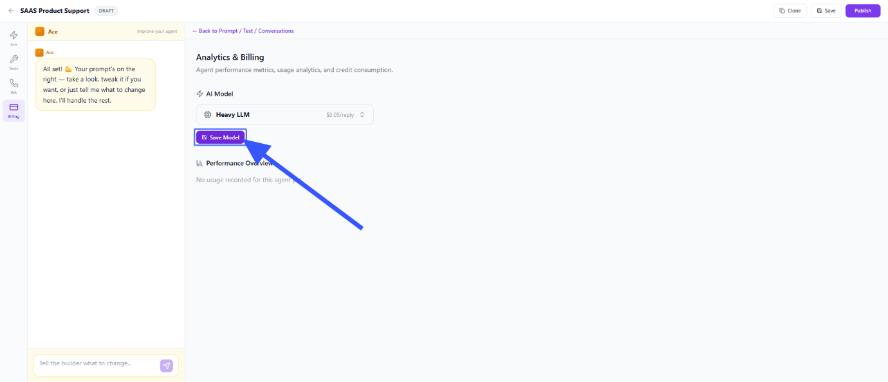
19.Click on Publish to finish the setup and Activate the AI Agent
